OVERVIEW

The Expenses app is designed to track expenses incurred by your employees in Bitrix24. Now you can efficiently track and receive expense reports submitted by your employees, as well as provide your feedback. You can launch the app from the following entities: leads, deals, contacts and companies. Only Expenses and Expense Reports are connected to a single entity.

WHAT IS NEW

Basic features

* Record/register expenses
* Aggregate expenses into reports
* Submit reports for approval

Visible Tabs

The following tabs are available to a regular user:

* Expenses
* Reports
* Reports Approval (see your own submitted reports)

The following tabs are available to a department manager:

* Expenses
* Reports
* Reports Approval (see submitted reports from your department)

Access to Expenses and Expense reports, created by other users

* Regular user does not see Expenses and Expense reports, created by other users
* Department manager sees Expenses and Expense Reports, created by his/her department employees
* Bitrix24 account administrator sees Expenses and Expense Reports, created by other users.

Important! The user must be in only one department. This version does not support the allocation of expenses and reports to several departments

MY EXPENSES, REPORTS AND REPORTS APPROVAL

Install Expenses app from Bitrix24 Marketplace. When the installation is complete, the app will display the page with information about Expenses and Bitrix24. Please, read this information and click «Finish» to finalize the installation.

Expenses

When the app is launched, the user will see the table with added Expenses for the selected client (Expenses tab). If the user hasn’t added his/her Expenses yet, the page will show an empty table with suggestion to add an Expense.

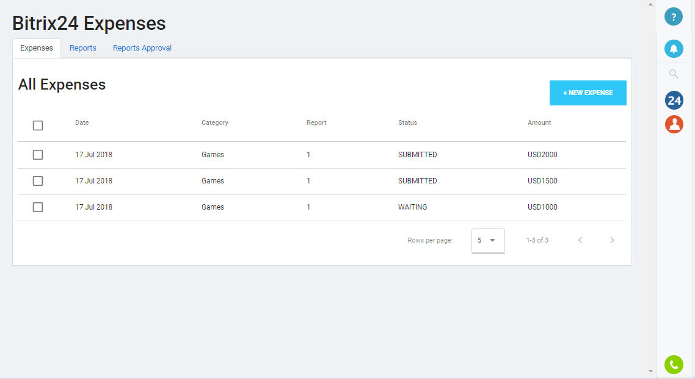

When clicking on checkboxes, the user is able to:

* Edit an Expense (this button is unavailable if this expense is included into the report sent for approval)
* Create an Expense Report based on Expense/Expenses (this button is unavailable if one of the selected Expenses is included into the Expense Report)
* Delete the Expense/Expenses (this button is unavailable if this Expense is included into the Expense Report sent for approval)

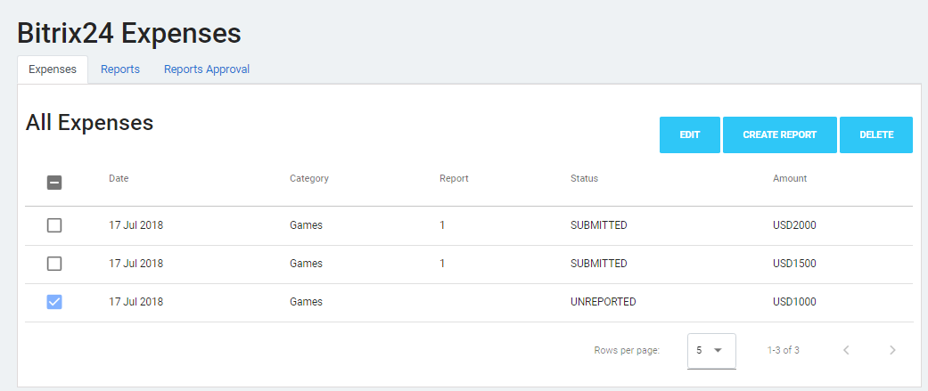

When clicking on a selected Expense, the user is able to:

* View the Expense details
* Edit the Expense (this button is unavailable if this Expense is included into the Expense Report sent for approval)
* Create an Expense Report based on the Expense (this button is unavailable if the Expense is included into the Expense Report)

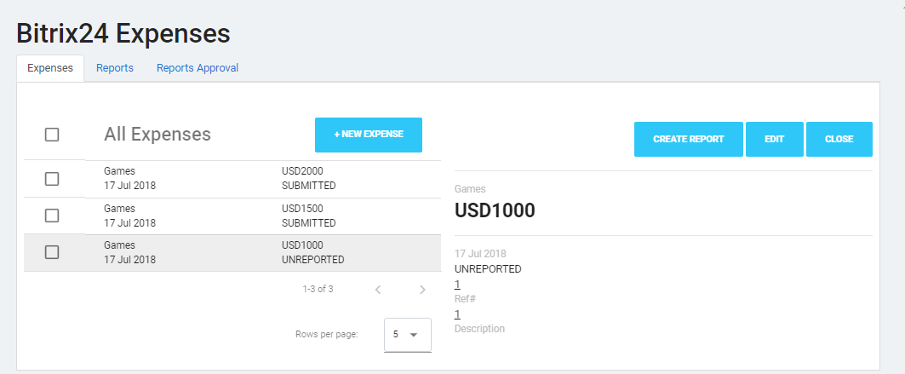

Expense details menu contains:

* Amount – numeric field (mandatory field)
* Date – date input field (mandatory field)
* Category – selection of existing categories/creation of a new category (optional field)
* Ref# - numeric field (optional field)
* Description – text field (optional field)

Expense details menu also shows status:

* Name of the Expense Report that includes this Expense
* This Expense revision history

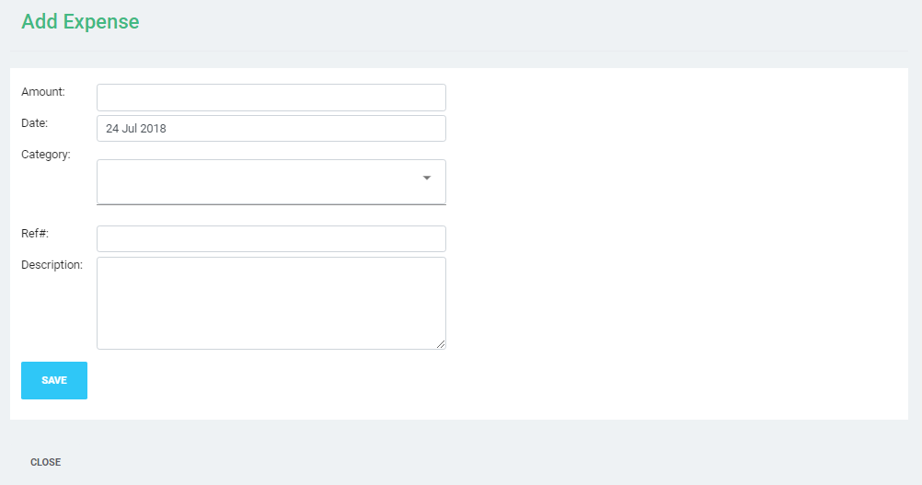

Expenses Reports

When clicking on the Reports tab, the user will see the table with his/her added Expense Reports for the selected client. If the user hasn’t added his/her Expense Reports yet, the page will show an empty table with suggestion to add an Expense Report.

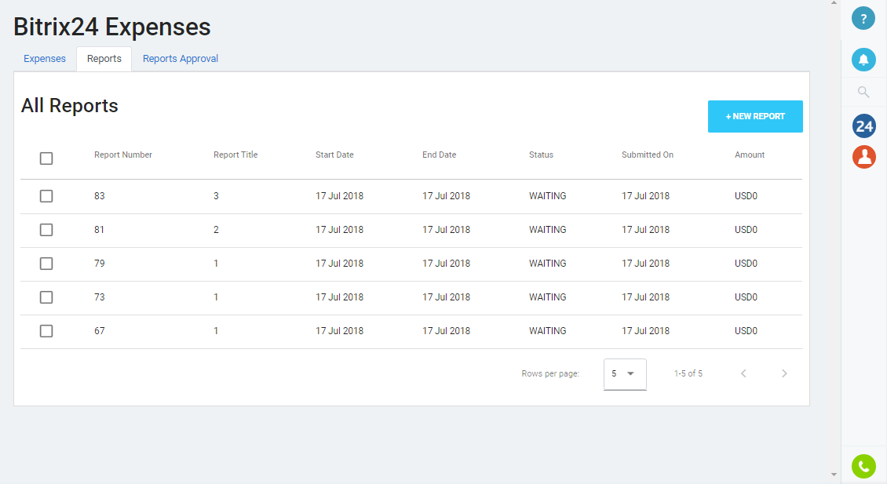

When clicking on checkboxes, the user is able to:

* Edit an Expense Report
* Submit the Report/Expense Reports for approval
* Delete the Report/Expense Reports

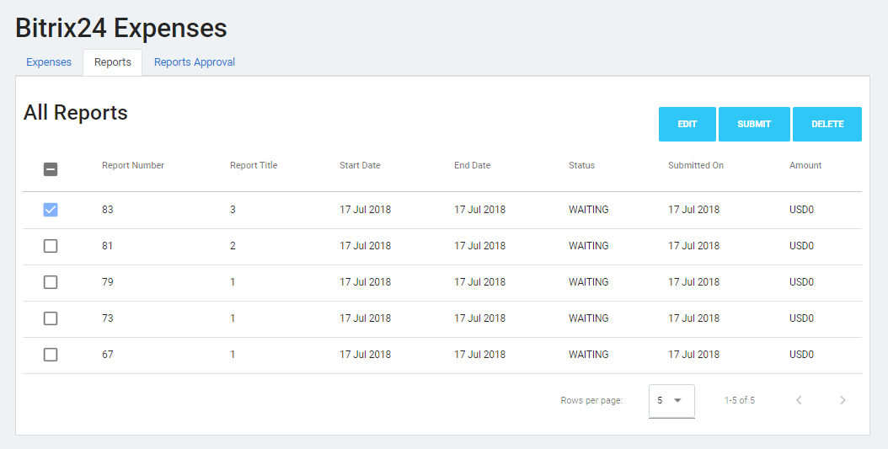

When clicking on a selected Expense Report, the user is able to:

* View the Expense Report details
* Edit the Expense Report
* Submit the Expense Report for approval

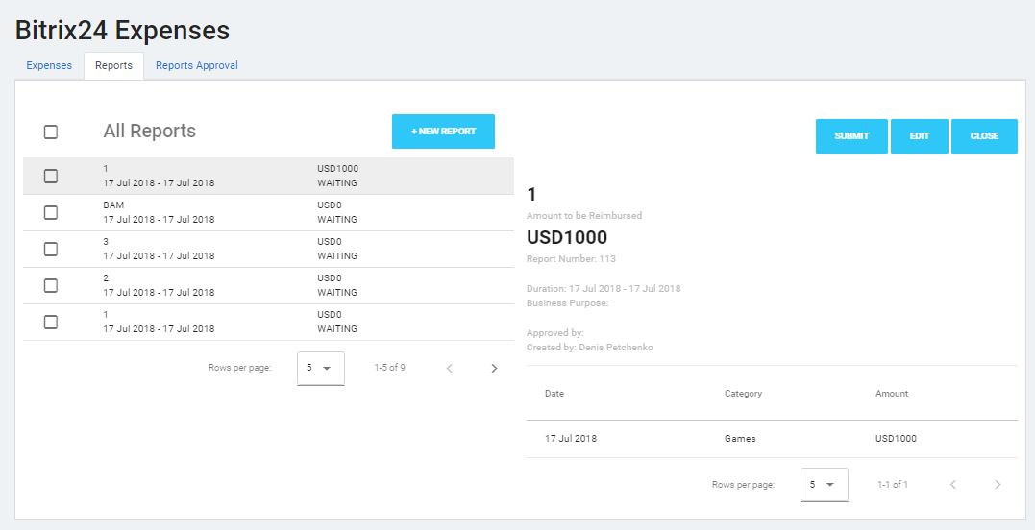

Expense Report details contain:

* Report Title – text field (mandatory field)
* Business Purpose - text field (optional field)
* Duration – date input field (mandatory field)

Also, the Expense Report details show the following:

* Report number (general for all Expense Reports)
* Name of the user who issued the Expense Report
* Name of the user who approved/did not approve the Expense Report
* List of Expenses added to this Expense Report (fields - date, category, amount)
* Expense Report revision history

Expense Reports statuses:

* Approved
* Not approved
* Pending approval

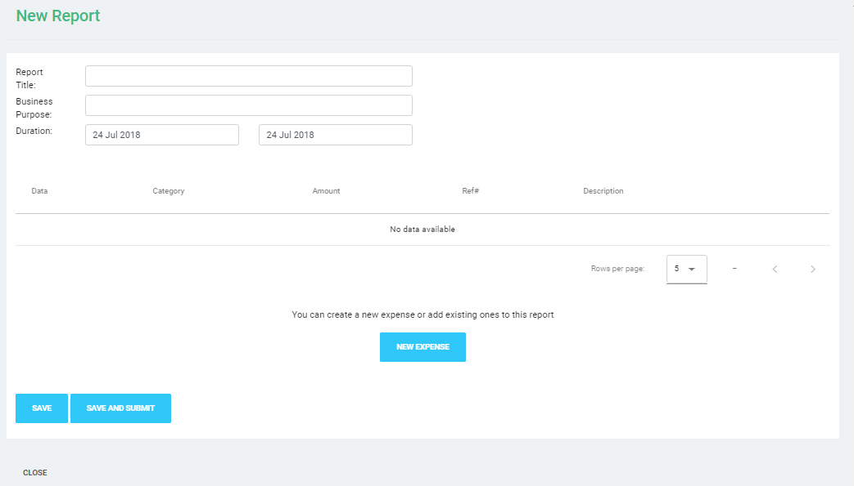

Expenses Reports Approval

When clicking on Reports Approval tab, the user will see the table with Expense Reports, sent for approval. If the user hasn't sent Expense Reports for approval yet, the page will show an empty table with the message specifying there are no Expense Reports sent for approval.

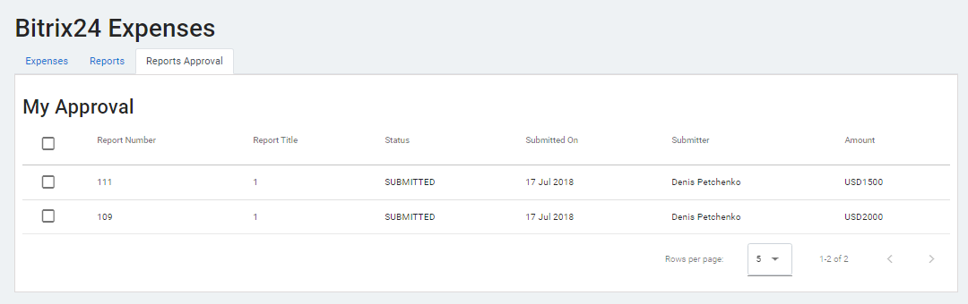

When clicking on checkboxes, the department supervisor is able to:

* Approve the Report/Reports, received for approval
* Decline to approve the Report/Reports, received for approval

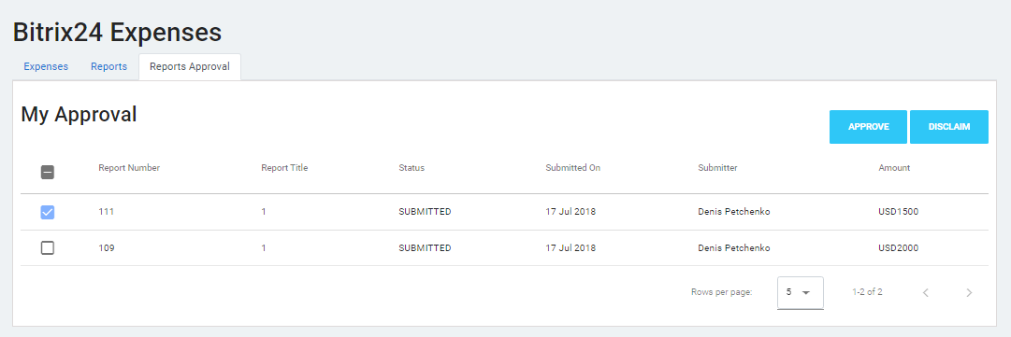

When clicking on the Expense Report, received for approval, the user is able to:

* View the details of the Expense Report, received for approval

The supervisor is able to:

* View the details of the Expense Report, received for approval
* Approve the Expense Report, received for approval
* Decline to approve the Expense Report, received for approval

